**The Parish of Saint Andrew**

**Orford with Longford**

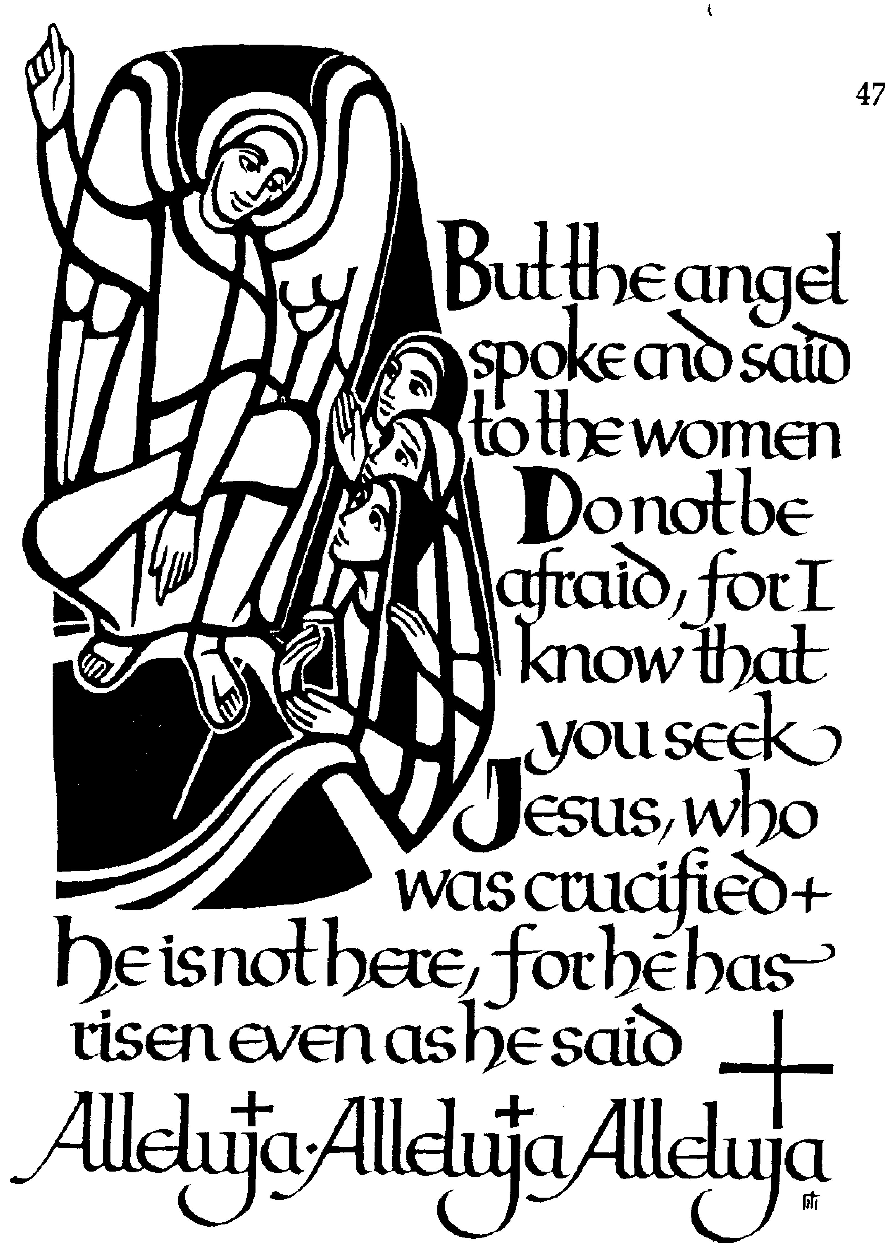

**Festival Eucharist**

**of the Resurrection**

**Easter Day 2019**

k

The Gathering

After the notices, please remain seated as we sing:

Were you there when they crucified my Lord?

Were you there when they crucified my Lord?

Oh! Sometimes it causes me to tremble, tremble, tremble,

Were you there when they crucified my Lord?

Were you there when God raised him from the dead?

Were you there when God raised him from the dead?

Oh! Sometimes it causes me to tremble, tremble, tremble,

Were you there when God raised him from the dead?

When the procession enters, please stand to sing:

**Introit Hymn**: 156 ‘Sing choirs of heaven’

At the Easter Garden:

Priest: In the name of the Father and of the Son and of the Holy Spirit. **Amen.**

Priest: Alleluia! Christ is risen.

All: He is risen indeed. Alleluia!

The priest blesses the Easter Garden, followed by:

**Hymn:** 137 vv 1, 2 and 4 ‘Alleluia, alleluia. Hearts to heaven...’

All: Almighty God, to whom all hearts are open, all desires known, and from whom no secrets are hidden: cleanse the thoughts of our hearts by the inspiration of your Holy Spirit, that we may perfectly love you, and worthily magnify your holy name; through Christ our Lord. Amen.

Reader: Christ our Passover lamb has been offered for us. Let us then rejoice by putting away all malice and evil, and confessing our sins with a sincere and true heart.

*After a period of silent reflection:*

All: Most merciful God,

Father of our Lord Jesus Christ,

we confess that we have sinned

in thought, word and deed.

We have not loved you with our whole heart.

We have not loved our neighbours

as ourselves.

In your mercy forgive what we have been,

help us to amend what we are,

and direct what we shall be;

that we may do justly, love mercy,

and walk humbly with you, our God. Amen.

Priest: Almighty God, who forgives all who truly repent, have mercy upon *you*, + pardon and deliver *you* from all *your* sins, confirm and strengthen *you* in all goodness, and keep *you* in life eternal; through Jesus Christ our Lord. **Amen.**

**All** 🎜 ***Glory, glory to God, glory to God in the highest*** *(twice)*

Glory to God in the highest, and peace to his people on earth; Lord God, heavenly King, almighty God and Father, we worship you, we give you thanks, we praise you for your glory

***Glory, glory to God, glory to God in the highest*** *(twice)*

Lord Jesus Christ, only Son of the Father, Lord God, Lamb of God, you take away the sin of the world. Have mercy on us; You are seated at the right hand of the Father; receive our prayer.

***Glory, glory to God, glory to God in the highest*** *(twice)*

For you alone are the Holy One, You alone are the Lord; You alone are the Most High, Jesus Christ. With the Holy Spirit, in the glory of God the Father.

***Glory, glory to God, glory to God in the highest*** *(twice)* **Amen**

**The Collect:** Lord of all life and power, who through the mighty resurrection of your Son overcame the old order of sin and death to make all things new in him: grant that we, being dead to sin and alive to you in Jesus Christ, may reign with him in glory; to whom with you and the Holy Spirit be praise and honour, glory and might, now and in all eternity. **Amen.**

The Liturgy of the Word

**A reading from the Acts of the Apostles** *(Acts 10. 34-43)*

Peter began to speak to those assembled in the house of Cornelius: ‘I truly understand that God shows no partiality, but in every nation anyone who fears him and does what is right is acceptable to him. You know the message he sent to the people of Israel, preaching peace by Jesus Christ – he is Lord of all. That message spread throughout Judea, beginning in Galilee after the baptism that John announced: how God anointed Jesus of Nazareth with the Holy Spirit and with power; how he went about doing good and healing all who were oppressed by the devil, for God was with him. We are witnesses to all that he did both in Judea and in Jerusalem. They put him to death by hanging him on a tree; but God raised him on the third day and allowed him to appear, not to all the people but to us who were chosen by God as witnesses, and who ate and drank with him after he rose from the dead. He commanded us to preach to the people and to testify that he is the one ordained by God as judge of the living and the dead. All the prophets testify about him that everyone who believes in him receives forgiveness of sins through his name.’

Reader: This is the word of the Lord.

All: Thanks be to God.

**Hymn:** *(remain seated)*  147 ‘Jesus Christ is risen today’

**A reading from the first letter of Paul to the Corinthians** *(1 Cor 15. 19–26)*

If for this life only we have hoped in Christ, we are of all people most to be pitied. But in fact Christ has been raised from the dead, the first fruits of those who have died. For since death came through a human being, the resurrection of the dead has also come through a human being; for as all die in Adam, so all will be made alive in Christ. But each in his own order: Christ the first fruits, then at his coming those who belong to Christ. Then comes the end, when he hands over the kingdom to God the Father, after he has destroyed every ruler and every authority and power. For he must reign until he has put all his enemies under his feet. The last enemy to be destroyed is death.

This is the word of the Lord.

All: Thanks be to God.

**Gradual Hymn:**  369 **‘**All people that on earth do dwell’

***wait*** *for tune of first line to be played* ***before starting to sing!***

# THE GOSPEL

Priest: I am the first and the last, says the Lord, and the living one;

I was dead, and behold I am alive for evermore

All 🎜 Alleluia, alleluia, alleluia!

Hear the Gospel of our Lord Jesus Christ according to John*(Jn 20. 1–18)*

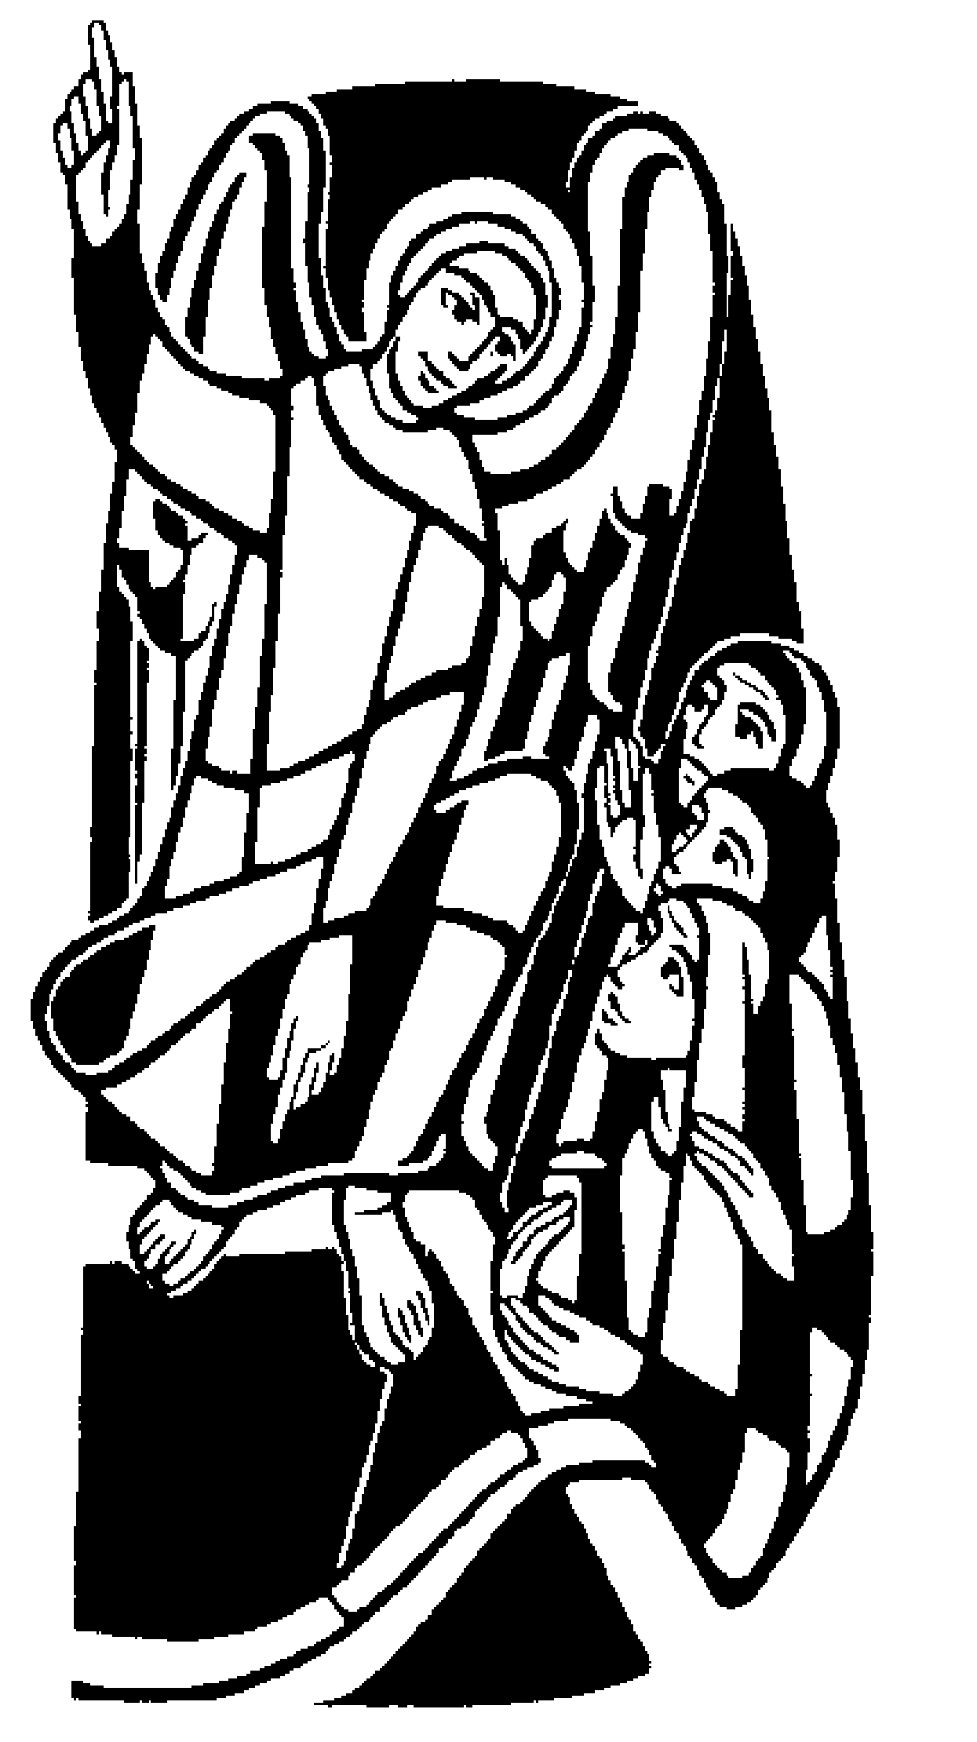 All 🎜 Glory to you, O Lord

Early on the first day of the week, while it was still dark, Mary Magdalene came to the tomb and saw that the stone had been removed from the tomb. So she ran and went to Simon Peter and the other disciple, the one whom Jesus loved, and said to them, ‘They have taken the Lord out of the tomb, and we do not know where they have laid him.’ Then Peter and the other disciple set out and went towards the tomb. The two were running together, but the other disciple outran Peter and reached the tomb first. He bent down to look in and saw the linen wrappings lying there, but he did not go in. Then Simon Peter came, following him, and went into the tomb. He saw the linen wrappings lying there, and the cloth that had been on Jesus’ head, not lying with the linen wrappings but rolled up in a place by itself. Then the other disciple, who reached the tomb first, also went in, and he saw and believed; for as yet they did not understand the scripture, that he must rise from the dead. Then the disciples returned to their homes. But Mary stood weeping outside the tomb. As she wept, she bent over to look into the tomb; and she saw two angels in white, sitting where the body of Jesus had been lying, one at the head and the other at the feet. They said to her, ‘Woman, why are you weeping?’ She said to them, ‘They have taken away my Lord, and I do not know where they have laid him.’ When she had said this, she turned around and saw Jesus standing there, but she did not know that it was Jesus. Jesus said to her, ‘Woman, why are you weeping? For whom are you looking?’ Supposing him to be the gardener, she said to him, ‘Sir, if you have carried him away, tell me where you have laid him, and I will take him away.’ Jesus said to her, ‘Mary!’ She turned and said to him in Hebrew, ‘Rabbouni!’ (which means Teacher). Jesus said to her, ‘Do not hold on to me, because I have not yet ascended to the Father. But go to my brothers and say to them, “I am ascending to my Father and your Father, to my God and your God.”’ Mary Magdalene went and announced to the disciples, ‘I have seen the Lord’; and she told them that he had said these things to her.

This is the Gospel of the Lord

All 🎜 Praise to you, O Christ

*The choir sing the anthem* ***"Surrexit Christus"****, the congregation joining in the chorus (in bold type):*

Choir Surrexit Christus alleluia!

Cantate Domino, alleluia!

All 🎜 Surrexit Christus alleluia!

Cantate Domino, alleluia!

1. All you heavens, bless the Lord.

Surrexit Christus alleluia!

Stars of the heavens bless the Lord

Cantate Domino, alleluia!

2. Give thanks to the Lord, for he is good,

Surrexit Christus alleluia!

for his love has no end.

Cantate Domino, alleluia!

3. The Lord is my strength, the Lord is my song;

Surrexit Christus alleluia!

he has been my Saviour.

Cantate Domino, alleluia!

4 I shall not die, I shall live,

Surrexit Christus alleluia!

I shall live and recount his deeds.

Cantate Domino, alleluia!

5. All you heavens, bless the Lord.

Surrexit Christus alleluia!

Stars of the heavens, bless the Lord.

Cantate Domino, alleluia!

# The Sermon

We stand to affirm our faith in the words of the Nicene Creed:

Priest: We believe in one God,

**All: the Father, the almighty, maker of heaven and earth, of all that is, seen and unseen.**

We believe in one Lord, Jesus Christ, the only Son of God, eternally begotten of the Father, God from God, Light from Light, true God from true God, begotten, not made, of one Being with the Father; through him all things were made. For us and for our salvation he came down from heaven, was incarnate from the Holy Spirit and the Virgin Mary and was made man. For our sake he was crucified under Pontius Pilate; he suffered death and was buried.

On the third day he rose again in accordance with the Scriptures; he ascended into heaven and is seated at the right hand of the Father. He will come again in glory to judge the living and the dead, and his kingdom will have no end.

We believe in the Holy Spirit, the Lord, the giver of life, who proceeds from the Father and the Son, who with the Father and the Son is worshipped and glorified, who has spoken through the prophets. We believe in one holy catholic and apostolic Church. We acknowledge one baptism for the forgiveness of sins. We look for the resurrection of the dead, and the life of the world to come.

Amen.

THE INTERCESSION

Priest: In the power of the Spirit and in union with Christ, let us pray to the Father: *(please kneel)*

The prayers are led by a member of the congregation. Each section ends:

Intercessor: Jesus stand among us

All: In your risen power.

After the final petition:

Intercessor: Merciful Father,

**accept these prayers**

**for the sake of your Son,**

**our Saviour Jesus Christ. Amen.**

**Please remember in your prayers:**

* **those who are ill:**  (4) Joan Clegg, Norma Lee, Stan Brand, Beryl Bentley, Kathy Rowan (3) Mark Shepherd, Marion Greatorex, Barbara Boscoe, Eileen Whitehead (2) Vera Wood, Gemma Rusling, Alex Halfpenny, Dorothy Pearson (1) Lynn Burman, Michael Stringer, Michelle Smith, Joyce Hetherington, Pauline Smith, Callum Foy
* **those who have died:**
* ***those whose year’s mind falls at this time:***

***Sunday:*** Bill Shaw, Val Carter

***Thursday:*** Reg Kenwright, Donna Davies

***Friday:*** John Davies, Linda Frangleton

THE PEACE *(please stand)*

Priest: The risen Christ came and stood among his disciples and said, ‘Peace be with you’. Then they were glad when they saw the Lord

The peace of the Lord be always with you

All And also with you

Priest: Let us offer one another a sign of peace.

Everyone is invited to exchange a sign of peace.

**The Liturgy of the Sacrament**

**Offertory Hymn:**  138 ‘At the Lamb’s high feast we sing’

During the singing of the hymn, a collection is taken, and bread and wine are brought to the altar.

**EUCHARISTIC PRAYER E**

Priest The Lord is here

All 🎜 His spirit is with us

Priest Lift up your hearts

All 🎜 We lift them to the Lord

Priest Let us give thanks to the Lord our God

All 🎜 It is right to give thanks and praise

Priest It is indeed right, our duty and our joy, always and everywhere to give you thanks, almighty and eternal Father, and in these days of Easter to celebrate with joyful hearts the memory of your wonderful works. For by the mystery of his passion Jesus Christ, your risen Son, has conquered the powers of death and hell and restored in men and women the image of your glory. He has placed them once more in paradise and opened to them the gate of life eternal. And so, in the joy of this Passover, earth and heaven resound with gladness, while angels and archangels and the powers of all creation sing for ever the hymn of your glory:

**All** 🎜 **Holy, holy, holy Lord; Holy, holy, holy Lord; God of power and might, heaven and earth are full of your glory. Hosanna, hosanna in the highest, Hosanna, hosanna in the highest. Blessed is he who comes in the name of the Lord, Blessed is he who comes in the name of the Lord, Hosanna, hosanna in the highest, Hosanna, hosanna in the highest.**

Priest: We praise and bless you, loving Father, through Jesus Christ, our Lord; and as we obey his command, send your Holy Spirit, that broken bread and wine outpoured may be for us the body and blood of your dear Son.

On the night before he died he had supper with his friends and, taking bread, he praised you. He broke the bread, gave it to them and said: Take, eat; this is my body which is given for you; do this in remembrance of me.

When supper was ended he took the cup of wine. Again he praised you, gave it to them and said: Drink this, all of you; this is my blood of the new covenant, which is shed for you and for many for the forgiveness of sins. Do this, as often as you drink it, in remembrance of me.

So, Father, we remember all that Jesus did, in him we plead with confidence his sacrifice made once for all upon the cross. Bringing before you the bread of life and cup of salvation, we proclaim his death and resurrection until he comes in glory.

Great is the mystery of faith:

All 🎜 Christ has died: Christ is risen: Christ will come again.

Priest: Lord of all life, help us to work together for that day when your kingdom comes and justice and mercy will be seen in all the earth. Look with favour on your people, gather us in your loving arms and bring us with the Blessed Virgin Mary, St Andrew and all the saintsto feast at your table in heaven. Through Christ, and with Christ, and in Christ, in the unity of the Holy Spirit, all honour and glory are yours, O loving Father, for ever and ever.

All 🎜 Amen, Amen, Amen, Amen

THE COMMUNION

Priest: Rejoicing in God’s new creation, let us pray with confidence as our Saviour has taught us:

All: Our Father, who art in heaven, hallowed be thy name; thy kingdom come; thy will be done; on earth as it is in heaven. Give us this day our daily bread. And forgive us our trespasses, as we forgive those who trespass against us. And lead us not into temptation; but deliver us from evil. For thine is the kingdom, the power and the glory, for ever and ever. Amen.

Priest: We break this bread to share in the body of Christ.

All: Though we are many, we are one body,

because we all share in one bread.

All 🎜 Lamb of God, you take away the sin of the world,

have mercy on us

Lamb of God, you take away the sin of the world,

have mercy on us.

Lamb of God, you take away the sin of the world,

grant us peace.

Priest: Alleluia. Christ our passover is sacrificed for us.

All: Therefore let us keep the feast. Alleluia.

Holy Communion is administered at the front of Church - please follow those around you. Everyone is warmly invited to receive Holy Communion at this Eucharist. Those who prefer to receive a blessing are also invited to come forward at the same time.

During the distribution of the Sacrament:

140 ‘Christ is alive! Let Christians sing’

136 ‘Alleluia, Alleluia, give thanks to the risen Lord’

**After Communion** and a short period of silence:

Priest: Let us pray:

All: Father of all, we give you thanks and praise, that when we were still far off you met us in your Son and brought us home. Dying and living he declared your love, gave us grace and opened the gate of glory. May we who share Christ’s body live his risen life; we who drink his cup bring life to others; we whom the Spirit lights give light to the world. Keep us firm in the hope you have set before us, so we and all your children shall be free, and the whole earth live to praise your name; through Christ our Lord. Amen

Priest: The God of peace, who brought again from the dead our Lord Jesus, that great shepherd of the sheep, through the blood of the eternal covenant, make you perfect in every good work to do his will, working in you that which is well-pleasing in his sight; and the blessing of God almighty, + the Father, the Son and the Holy Spirit, be among you, and remain with you always. **Amen.**

**Recessional Hymn** 157 ‘The day of resurrection’

The Dismissal

Priest: Go in joy and peace to love and serve the Lord. Alleluia! Alleluia!

All: In the name of Christ. Alleluia! Alleluia!

✠ ✠ ✠ ✠ ✠ ✠ ✠ ✠ ✠ ✠ ✠ ✠ ✠ ✠ ✠ ✠ ✠ ✠ ✠ ✠ ✠

Services and Notices for this week:

Tuesday 23rd: 10.00am Flowere arranging course begins in the Hall

No Parish Office and No Choir Practice this evening

Wednesday 24th: 7.00pm Eucharist

Thursday 25th: 10.30am Eucharist

**Next Sunday: Second Sunday of Easter**

(28th April) **10.00am Sung Eucharist**

**11.30am Annual Parochial Meeting in church**

**Tea and Coffee (and Juice)** will be served at the back of church after the service. Do stay and join us.

**Thank you** to everyone who helped clean and decorate for Easter, including the Easter Garden, and who helped with the services this week.

**The Charity Shop**  will be open as normal on Wednesday

**Flower Arranging course**  will be held in the Hall, starting on Tuesday at 10am. It is open to everyone, is **completely free** (including flowers for your arrangement which you can then take home). Please come and try it out – it will be within everyone’s ability. If you’re interested, please let Fr Michael know **this morning**. Thank you.

**The Annual Meeting**  will be held in church next Sunday (28th April) following the Sung Eucharist. It’s an important occasion in the life of St Andrew’s and we hope you will stay. It lasts about 40 minutes.

Please think about people you wish to nominate for church wardens and members of the PCC. It would help if those nomination forms could be filled in before the meeting – ideally before you leave today.

**Readings for Easter Day 2019 21st April 2019**

**A reading from the Acts of the Apostles**

Peter began to speak to those assembled in the house of Cornelius: ‘I truly understand that God shows no partiality, but in every nation anyone who fears him and does what is right is acceptable to him. You know the message he sent to the people of Israel, preaching peace by Jesus Christ – he is Lord of all. That message spread throughout Judea, beginning in Galilee after the baptism that John announced: how God anointed Jesus of Nazareth with the Holy Spirit and with power; how he went about doing good and healing all who were oppressed by the devil, for God was with him. We are witnesses to all that he did both in Judea and in Jerusalem. They put him to death by hanging him on a tree; but God raised him on the third day and allowed him to appear, not to all the people but to us who were chosen by God as witnesses, and who ate and drank with him after he rose from the dead. He commanded us to preach to the people and to testify that he is the one ordained by God as judge of the living and the dead. All the prophets testify about him that everyone who believes in him receives forgiveness of sins through his name.’

Reader: This is the word of the Lord.

All: Thanks be to God.

**Hymn:** *(remain seated)*  147 “Jesus Christ is risen today”

**second reading on following page/**

**A reading from the first letter of Paul to the Corinthians**

If for this life only we have hoped in Christ, we are of all people most to be pitied. But in fact Christ has been raised from the dead, the first fruits of those who have died. For since death came through a human being, the resurrection of the dead has also come through a human being; for as all die in Adam, so all will be made alive in Christ. But each in his own order: Christ the first fruits, then at his coming those who belong to Christ. Then comes the end, when he hands over the kingdom to God the Father, after he has destroyed every ruler and every authority and power. For he must reign until he has put all his enemies under his feet. The last enemy to be destroyed is death.

Reader: This is the word of the Lord.

All: Thanks be to God.

#### Intercessions for Easter Day (for adult reader) 21st April 2019

##### Priest: Let us pray

*(all kneel)*

Leader: Loving Father, we praise you for the resurrection of your Son Jesus Christ from the dead. May we respond with joy and live as those who believe in the triumph of the cross and the power of the resurrection.

We pray for the spread of the faith around the world. May your Church live each and every day as Easter people. Equip us with your gifts of grace and may our joy overflow to those around us.

Bless Paul our bishop, and all your Church in the service of Christ.

Jesus stand among us

All: In your risen power.

Leader: We pray for those who at this season are preparing to receive in baptism your Son’s new life by water and the Spirit, for those who are have recently been confirmed, for those exploring new avenues in ministry and for those whose faith has lapsed and now feel drawn to you.

We pray that your peace may descend upon the world, and for greater understanding and justice among and within the nations.

Be with the people of Southern Africa at this time and bless the leaders of the nations with generous hearts to help those in need.

Jesus stand among us

All: In your risen power.

Leader: We pray for all whom we love, both those who live locally and those live at a distance. May their eyes be opened to see and believe the glory of our risen Lord.

Jesus stand among us

All: In your risen power.

Leader: We pray for all who suffer pain and anguish, and for those who care for them. Bless the work of the Samaritans, Child Line and other counselling services.

We continue to pray for Joan Clegg, Norma Lee, Stan Brand, Beryl Bentley, Kathy Rowan, Mark Shepherd, Marion Greatorex, Barbara Boscoe, Eileen Whitehead, Vera Wood, Gemma Rusling, Dorothy Pearson, Michelle Smith, Joyce Hetherington, Pauline Smith, Callum Foy and any we now mention in the silence of our own hearts...

Grant them the faith to reach out towards the healing wounds of Christ and be filled with his peace.

Jesus stand among us

All: In your risen power.

Leader: We remember before you all who have died with confidence in the resurrection and especially those dear to us…

By name, we pray for Bill Shaw and Val Carter whose year’s mind falls at this time. Unite us with all your faithful people in your undying love.

Jesus stand among us

All: In your risen power.

Leader: Join our voices, we pray, Lord our God, to the songs of all your saints in proclaiming that you give us the victory through Jesus Christ our Lord.

Merciful Father,

**All: accept these prayers**

**for the sake of your Son,**

**our Saviour Jesus Christ. Amen**

#### Intercessions for Easter Day [for Sunday School to lead] 27th March 2016

##### Priest: Let us pray

*(all kneel)*

Leader: We thank you, Lord Jesus, for coming into our world and showing us how much you love us. You rose to new life and filled us with joy.

We pray for the spread of the good news around the world. Help us to be your Easter people.

Bless Paul our bishop, and all your Church in the service of Christ.

Jesus stand among us

All: In your risen power.

Leader: We pray for those who are preparing for baptism or confirmation, and for those whose faith has lapsed and now feel drawn to you.

We pray that your peace may descend upon the world, and for justice for all people. Bring peace to Syria. Bless those who suffer. Be with the people of Belgium..

Jesus stand among us

All: In your risen power.

Leader: We pray for all whom we love, both those who live locally and those live at a distance. May their eyes be opened to see and believe the glory of our risen Lord.

Jesus stand among us

All: In your risen power.

Leader: We pray for all who suffer and for those who care for them.

We remember Etheline Worrall, Rhia Roberts, Su Williams, Nancy Parker, Eleanor Moran, Lynn Burman, Michael Stringer, Paul Hogden, Michelle Smith, Mary Lowe, May Jones, Bill Williams, Doris Jepson, Rob Mudd, Mark Shepherd, Marion Greatorex, Jacqueline Willington, Eric Tickle and any we now mention in the silence of our own hearts...

Give them courage and strength at this time.

Jesus stand among us

All: In your risen power.

Leader: We remember before you all who have died and especially those dear to us. We pray for Julie Newman and, Les Smith who died recently and for Jean Holcroft, Eunice Peacock and George Dodd whose year’s mind falls at this time.

Jesus stand among us

All: In your risen power.

Leader: Join our voices, we pray, Lord our God, to the songs of all your saints in proclaiming that you give us the victory through Jesus Christ our Lord.

Merciful Father,

**All: accept these prayers**

**for the sake of your Son,**

**our Saviour Jesus Christ. Amen**

**Blessing of the Easter Garden 2019 (give Peter a copy)**

After the notices, please remain seated as we sing:

Were you there when they crucified my Lord?

Were you there when they crucified my Lord?

Oh! Sometimes it causes me to tremble, tremble, tremble,

Were you there when they crucified my Lord?

Were you there when God raised him from the dead?

Were you there when God raised him from the dead?

Oh! Sometimes it causes me to tremble, tremble, tremble,

Were you there when God raised him from the dead?

When the procession enters, please stand to sing:

**Introit Hymn**: 156 ‘Sing choirs of heaven’

*At the garden:*

Priest: In the name of the Father and of the Son and of the Holy Spirit.

All: Amen.

Priest: Alleluia! Christ is risen.

All: He is risen indeed. Alleluia!

Priest: The angel said to the women: ‘Do not be afraid; for I know that you seek Jesus who was crucified. He is not here; for he has risen as he said.”

Blessed are you, Lord God of all creation, the Father of our Lord Jesus Christ.

To you be glory now and for ever.

In your great mercy, you have given us new birth into a living hope

By the resurrection of Jesus Christ from the dead.

By your blessing may we who have prepared this garden in celebration of his victory be strengthened in faith, know the power of his presence, and rejoice in the hope of eternal glory, Blessed be God, Father, Son and Holy Spirit.

Blessed be God for ever.

Risen Lord Jesus,

as Mary Magdalene met you in the garden on the morning of your resurrection,

so may we meet you today and every day:

speak to us as you spoke to her;

reveal yourself as the living Lord;

renew our hope and kindle our joy;

and send us to share the good news with others. Amen.

**Hymn:** **137 vv 1, 2 and 4 only** ‘Alleluia, alleluia’

All: Almighty God,

to whom all hearts are open…